scale focus project

Documentation



Contents

Authors 2

Summary 2

Description of the application 2

Table with some of the most important functions 2

Diagram of the program 3

Milestones in the realization 4

Used resources 4

Conclusion 4

# Authors

* Ema Martinova Mateva - [emmateva18@codingburgas.bg](mailto:emmateva18@codingburgas.bg), 10G class
* Aleksandar Galinov Dinev– [agdinev18@codingburgas.bg](mailto:agdinev18@codingburgas.bg), 10V class
* Georgi Stoychev Koradov– [gskoradov18@codingburgas.bg](mailto:gskoradov18@codingburgas.bg), 10V class
* Georgi Nedyalkov Georgiev- [gngeorgiev18@codingburgas.bg](mailto:gngeorgiev18@codingburgas.bg), 10A class
* Zhenya Ivelinova Yordanova - [ziyordanova18@codingburgas.bg](mailto:ziyordanova18@codingburgas.bg), 10G class

# Summary

## Description of the application

Our application is created with the help of the development environment of VS 2019. We made a game more known as “Bulls and cows” with the programming language C++. The user needs to guess coordinates (random numbers in exact order) and they have limited tries to guess. They get information about how many numbers they have guessed and also how many are in the correct place after each try.

## Table with some of the most important functions

|  |  |  |  |
| --- | --- | --- | --- |
| Name of function and its type | Arguments | Short description | Returned value |
| bool checkCoordinates | string coordinates, char min, char max, int size,  bool duplicates | Checks if the coordinates include duplicates, chars out of the range or spaces | Returns boolean |
| void checkForWrongInput | int& variable | Forces you to enter a number not string | Returns nothing |
| void generateRandomNumbers | int* numbers | Generates four random numbers | Returns nothing |
| void asteriskInput | string& coordinates | Forces you to enter a number but displays it like a password with “*” | Returns nothing |
| void color | int color | Gives color to the console | Returns nothing |
| void guessDisplay | int guessedNumAndPos, int guessedNum,  int guessedNumAndPosMax,  string guess | Displays the guessed numbers in an understandable way | Returns nothing |
| void userInputCoordinates | string& coordinates | Forces you to write proper coordinates | Returns nothing |
| void displayWarnings | int error1, int error2, int error3, int error4, char min,  char max, int size) | Displays the warnings why your data is not accepted | Returns nothing |
| void customGameValidation | int& variable, int min, int max | Forces you to enter a number in exact range | Returns nothing |
| void headerGameInterface | int guessedNumAndPos, int guessedNum,  vector<GUESS> guesses, int playerID | Displays the header of the game | Returns nothing |
| void gameInterface | vector<GUESS>guesses, int tries, int guessedNumAndPosMax, int guessedNumMax,  int playerID | Displays the interface of the game | Returns nothing |
| void customMode | No arguments | The function forces you to type your own settings with which you want to play the game and calculates the guessed numbers you have in your coordinates | Returns nothing |
| void defaultMode | int choice | The function forces you to type coordinates and calculates the guessed numbers in them | Returns nothing |
| void showMenu | No arguments | Displays the menu | Returns nothing |
| bool menu | No arguments | Main menu | Returns boolean |
| Void game | No arguments | Main function which starts the main menu | Returns nothing |

## Diagram of the program

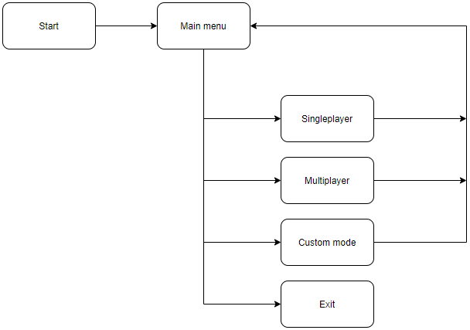

## Milestones in the realization

Before we started, we had to make a plan how to make the program. That included:

* Deciding what to do
* Searching for similar ideas
* Distribution of tasks in GitHub
* Programming
* Testing

## Used resources

For the implementation we used **Microsoft Visual Studio 2019** and **Visual Studio Code**. For sharing the code between us and for working together, we used **GitHub**. For discussing ideas, roles of the members in the team and other things connected with the organization we used **Microsoft Teams** and also **GitHub**.

# Conclusion

We had enough time to make the project. In conclusion, we were well-organized and worked under pressure because it is hard to make a user-friendly bug-free program and site.